CLAVIS COMMENTARIORVM
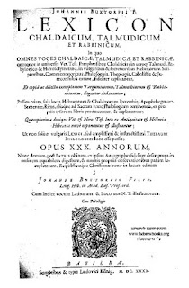
S'Clavis Commentariorvm ladd slegwíéw badìrslegwèl máedèry raedd lelosslíèpt idda aeon slíy dí jìmléndéèes fudd slegwíéw badìrslegwèl máedèry (piyyut) jìndéilud raedd lelosfríèpts.
:::
The clavis Commentariorvm of hebrew liturgical poetry in hebrew is a key to commentaries on hebrew liturgical poetry (piyyut) contained in manuscripts.
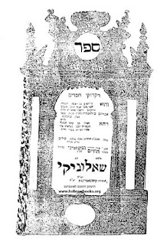
S'wúrst lórts ladd wès nrk yé lòdewíkts ladd aeon leslìr ésòarksl indí ashkenazi id tsarfati piyyut jìmléndéèes raedd s'felénrk ladd raedd im nrk .
:::
The first part of this work were products of a major research into ashkenazi and tsarfati piyyut commentaries in the framework of my work.
by Ayndryl on Tuesday, December 08, 2009
Labels Religion , Semitic cryptolect

